Membership Application
 | 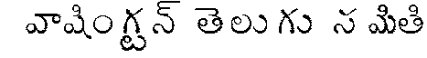  A registered Non-Profit Organization  www.watsweb.org

Renewing Membership New Membership.

Membership Number:TOBE ASSIGNED Membership Year: 2009
First Name (please print)
Last Name (please print)
Email** (please print)
Street Address**
(please print)
City (please print)
Zip (please print)
Home Phone**
Cell Phone**
Spouse First, Last Name
Spouse Email **
Number of Children
Do Do Not Publish my entry in the WATS magazine.

Additional Donation* $
Membership Category (Please Check One of the 4 options)
Annual Family $25 (suggested donation)Annual Individual $15 (suggested donation)
Not interested in Membership Already a Member for the current year

Please make checks payable to Washington Telugu Samithi or WATS and mail to
Washington Telugu Samithi PO Box 3322, 1171 Bellevue Way NE, Bellevue, WA 98004

* WATS is a non-profit organization. All donations are tax deductible (TAX-ID 43-1953762)
**WATS respects your privacy and does not share its members email, address or phone numbers with any other organization.

